Anime movies. The roots and stereotypes.

What do adults and teens in Saint-Petersburg think about anime movies in general. What stereotypes exist? And what genres are there?

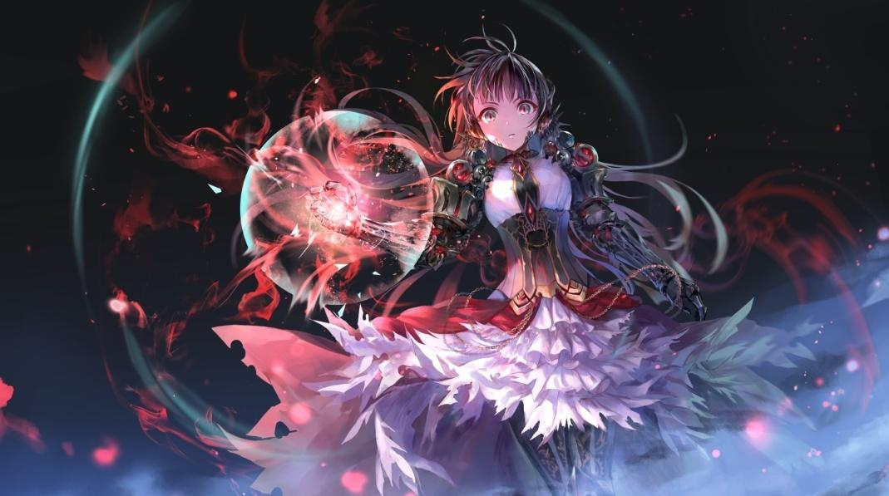
Anime refers specifically to animation from Japan or as a Japanese-disseminated animation style often characterized by colorful graphics, vibrant characters аnd fantastical themes. One of the main features of drawing anime — unnaturally big characters eyes.

There are different myths about this type of animation in SPb. One of them is that anime is a Chinese movie only for adults. That’s not true at all! First of all, anime came from Japan. At XX century Japanese animators started their experiments with western technologies and the oldest extanted animation is “Katsudo Shashin”.
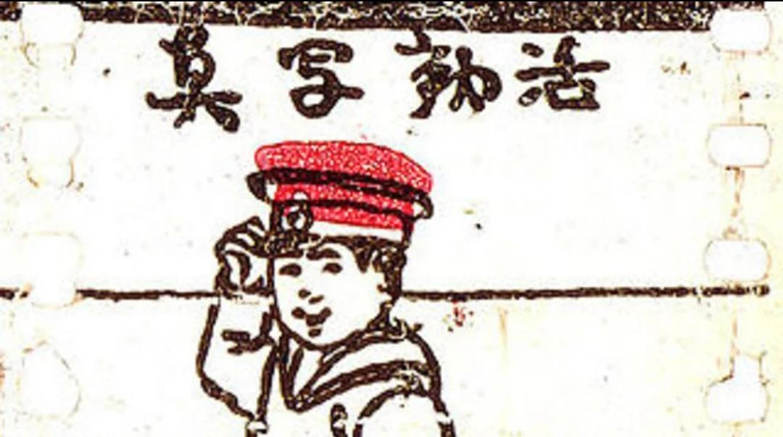

Secondly, there are different animes for different audience and different ages, like in usual cinematography.
The most popular are:
- Codomo. This type is for children, main points are : drawings is close to west animation and even not every anime fan can say that this movies are anime.
In this movies main themes are traveling, parents love, cute animals and kindness.
The most popular in Russia are The Bee Maya, My neighbor Totoro
Movie Neighbor Totoro tells us the main spirit of the forest which name is Totoro. He contacted only with children. This feature communicated with village girls and helped them in difficult situation. Their mother was in hospital and doctors said that she did not come home in near future. After this news girls quarreled and one of them ran away in the forest. The other girl asked for help Totoro and he found her sister. Then a cat spirit took girls to the hospital. In the end mother recovered and all were happy.

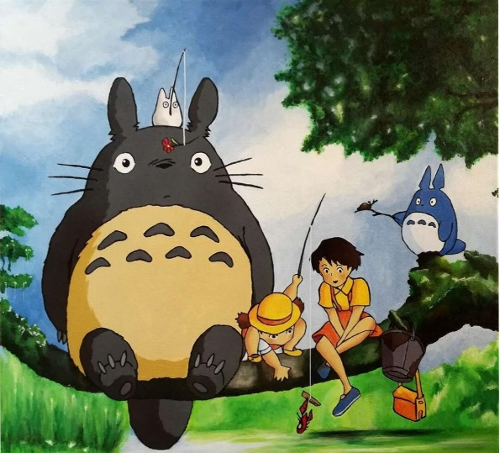

- Shojo is for girls 12-18. The main character usually a girl and main topic is her life and her becoming a person. There are love relationships in different degree of proximinity. The most concentration is on the development of characters. On of the features is strong romantic or really humorous drawing. Examples: Sally The Witch, Sailor Moon.
This story is about very strong love that passed through the centuries and defeated evil. The main heroine is a reincarnated of a Moon’s princess. She was a normal schoolgirl but she met a talking cat which awakened her magic abilities. Then she acquainted other reincarnated girls and prince from her past life and they began their fight with evil for the Earth safety.
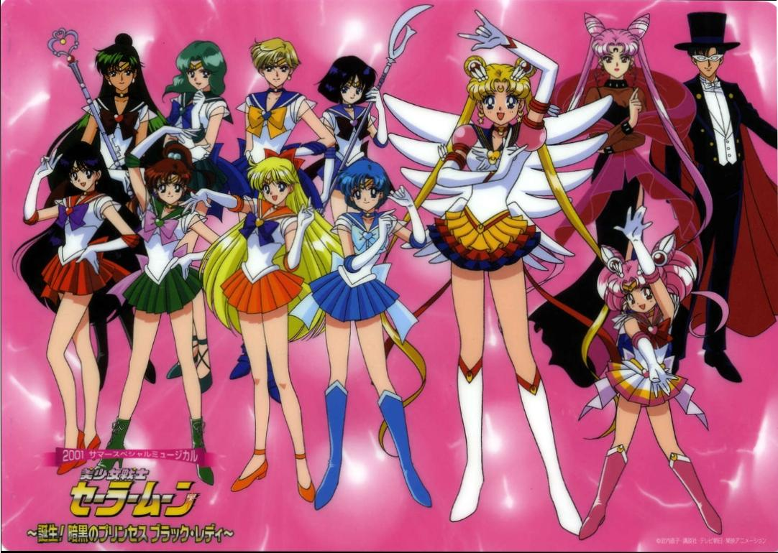

- Seinen is a genre for boys 12-18. The main character usually a brave purposeful boy with an unreal luck. Main topics are: men’s friendship, partnership, competitions, sport or martial arts.
Examples: Fairy Tail, Naruto, Soul Eater.
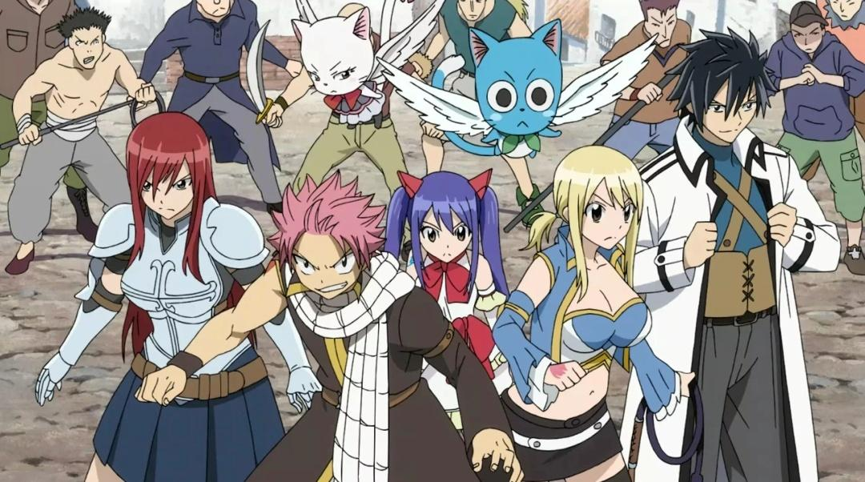
Fairy Tail is my first anime. It’s about one very active and friendly magic guild and their adventures. All people in this guild think about each other and if someone have problems all friends will help. People from this guild never gave up and always achieved their goals.

Another types are seinen ( for men 25-40), josei (for women 25-40), hentai ( for people older than 18), spokon (only about sport), maho sogo (about girls magicians), etc.

Another myth says that anime destroys people’s mind. But my question is «How???» It’s only an animation like a normal cinema so if in some anime there are bloody or another not normal scenes there will be a warning about it in the description, so people should only read it before watching.

What is more, the majority of adults in Saint Petersburg suggest that anime makes teens stupid. They think if teen is waching anime he or she won't study, do their work. Some of adults say that teens become addicted to it but what's wrong with having a hobby? People listen music, sing songs, reading books, learning foreign languages, so what's wrong witn watching Japanese movies? There are lots of clever students who is watching anim. And I'm one of them. Anime helps to relax, to develop imaagination. Sometimes teens after watching anime get inspired and start doing sport or other activities! Some people from the Russian schools start playing volleyball after watching anime «Haikyuu» and even had some good results.

In conclusion, it’s important to say that anime is already a part of world’s culture along with cinematography and writing. And people shouldn’t only listen different rumors. Instead they should create their own opinion. As wise people said “Don not judge book only by its cover”.

